How to use the code?
Overview
1.1 Purpose / Aim
- Implement a phase-field/cohesive zone model for fracture in Abaqus through a user element formulation (UELMAT) and Abaqus built-in cohesive element.
- Automate preparation of Abaqus input files using MATLAB (convert/update .inp, inject keywords/properties/SDVs, and batch run simulations).
- Provide consistent output fields (e.g., damage/phase field, history variables) for post-processing.
1.2 Scope
- Small/finite strain, quasi-static and brittle fracture.
- Supported element families (e.g., 2D and 3D elements).
1.3 Deliverables
- Updated .inp ready for Abaqus submission
- Abaqus .odb outputs containing the key internal variables
- Logs and job files for reproducibility

2. Code Structure
2.1 Components
- Fortran (UELMAT/UEL): core element routine (stiffness + residual, internal variables, coupling).
- Fortran (UMAT used for visualization, if applicable): transfers UEL internal variables to ABAQUS output fields (STATEV).
- MATLAB preprocessor: reads a base .inp, injects/updates:
  - user element definitions
  - material/UEL properties
  - SDV allocation (*DEPVAR)
  - element sets / sections
  - job naming conventions and batch configuration
- MATLAB run script: submits Abaqus jobs with user=...for.
2.2 Required inputs
- Base Abaqus .inp file (geometry, mesh, steps, BCs, loads).
- Material/phase-field parameters list (e.g., $E,ν,l_{c},G_{c}$, AT1/AT2 models).
- Abaqus installation with Fortran compiler configured.
2.3 Step-by-step workflow
- Prepare a base .inp in Abaqus/CAE:
  - Mesh requirements and element type assumptions (state them). Set and section name should start with Coh and Uel.
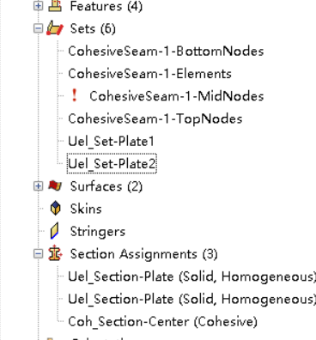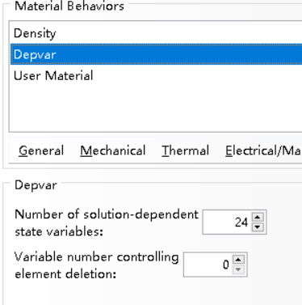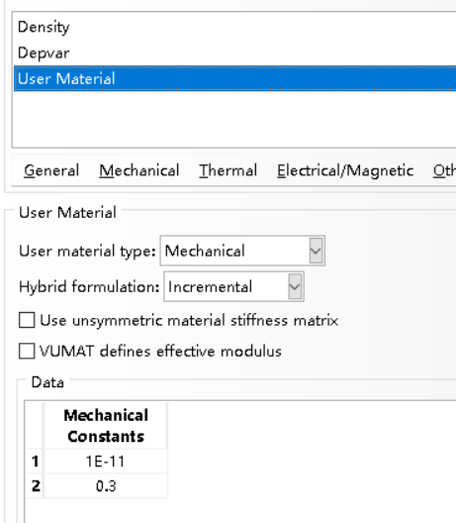
Detailed information can be found in the matlab code. The source code is from this paper: Molnár, G., Gravouil, A., Seghir, R., & Réthoré, J. (2020). An open-source Abaqus implementation of the phase-field method to study the effect of plasticity on the instantaneous fracture toughness in dynamic crack propagation. Computer Methods in Applied Mechanics and Engineering, 365, 113004.

- Configure parameters in MATLAB:
  - Set material/phase-field constants.
  - Set element set names and insertion anchors.
- Generate updated input:
  - update_inp_for_uel(base.inp, updated.inp, opt)
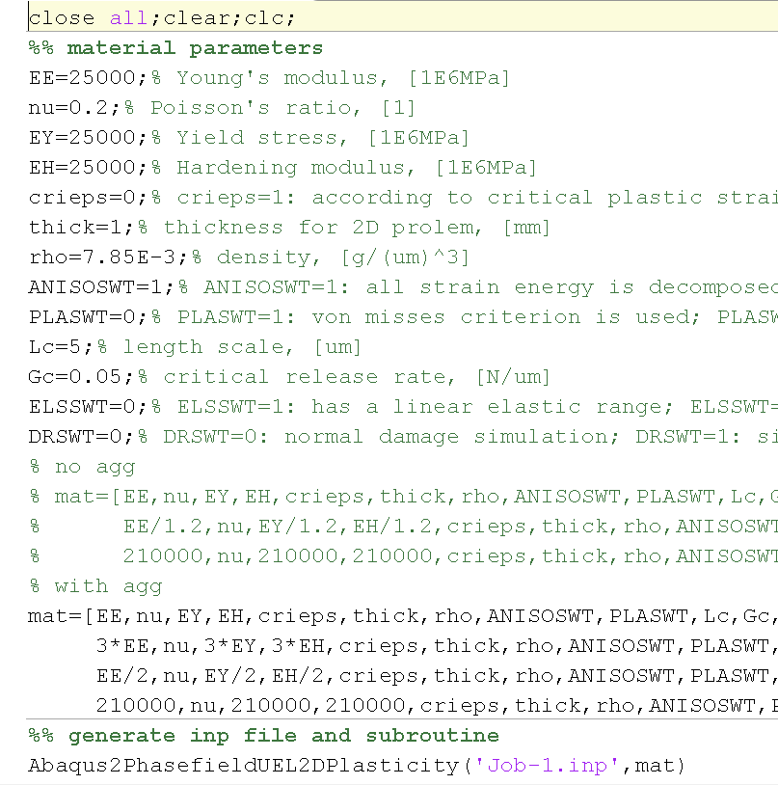
- Run Abaqus:
  - run_abaqus_job(jobName, updated.inp, uelmat.for)
- Post-process in Abaqus/CAE or MATLAB/Python:
  - Plot $ϕ$, track crack length proxy, extract force–displacement, etc.

